COURSEWORK 1

Databases – CMP020C106S

17 March 2023

Syed Abdul Rafey Saleem

SAL21533673

**Table of Contents**

Introduction ------------------------------------------------------------------------------------ 03

Methodology ----------------------------------------------------------------------------------- 03

Results ------------------------------------------------------------------------------------------- 04

Conclusion -------------------------------------------------------------------------------------- 05

**Introduction**

In this coursework, we were asked to create a database system to run a business. To start off, I planned a business idea to do my working on. I am creating a database system for an event organizing company named as RYAS Corporate. This company organizes events based on the requirements of the client in one of its many locations. This is a vast business which means that RYAS Corporate takes clients from more than 10 different cities in England with more than 20 locations in each cities. This business is still in the process of expanding and therefore has a lot of data to manage.

The basic working of the business is that the client first contacts the company and asks for availability for their event to be arranged. The company then checks the availabilities of the locations and all the companies and artists involved in the event.

**Methodology**

RYAS Corporate has to handle a lot of data to run their business and therefore needs a database management system to manage their database. As the business needs to keep in note all of the companies’ data which are working with them. Not only storing but it also needs to constantly store and manage the availability of these organizations/ companies as well. With these companies’ data and data related to the clients and events, the company requires use of relational database as all the data needs to be synchronized in order for things to work totally fine. I started by making the Entity Relationship Diagram to clearly summarize the database system.

So, I, firstly listed down all the entities that the company needs the data for. After having listed down all the entities I noted all the attributes that are linked to each of the entities. Then before jumping into giving relation between each entities, I, classified all the entities and attributes according to their characteristics.

Having done that, I added the relation between each entity and characterized the relationship between them.

With the help of the ER diagram I also created the relational data model for this data base which was really helpful in illustrating the relation of tables and records.

**Results**

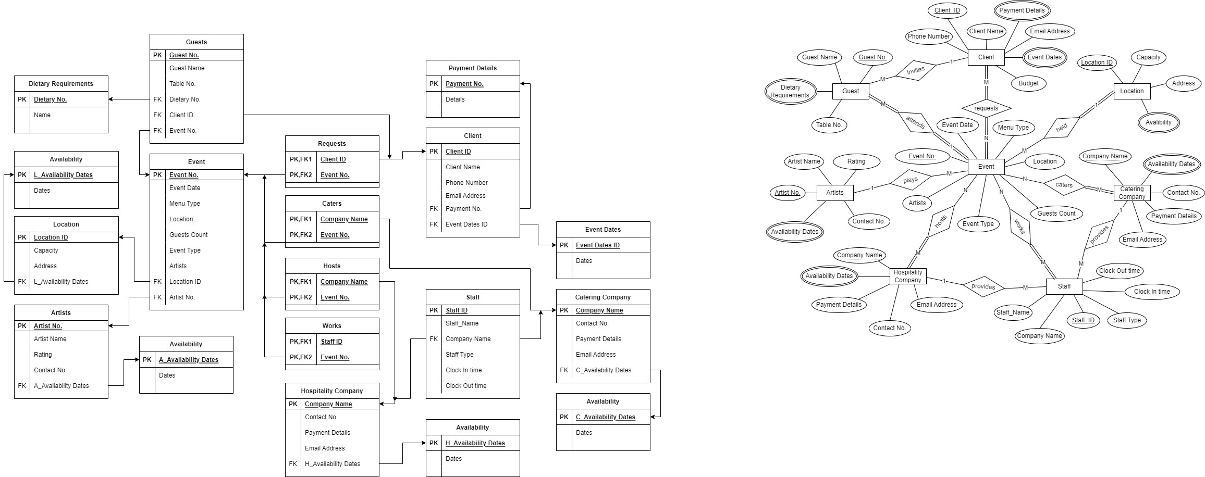The ERD and Relational data model of the business that I came up with is as following:



**Conclusion**

Apart from already storing and managing the database, I think ERD and Relational model of database system is a great way to represent all the relationships between the data. This also helped me get a better understanding of the databases.